
THE POSTS AND TELECOMMUNICATIONS INSTITUTE OF TECHNOLOGY
DEPARTMENT OF INFORMATION TECHNOLOGY 1

DEPARTMENT OF INFORMATION TECHNOLOGY 1

FINAL REPORT

Class | : | E22HTTT
Subject No | : | 12
Student ID | : | B22DCVT214
Name | : | Nguyễn Việt Hoàng

Requirement
1. Glossary list
No. | Name | Definition
Related to human
1 | User | A person(customer, management staff, warehouse staff, saler) who can use their credentials to log into the website and use the website functions
2 | Customer | A user who can register as a member, search, order goods online, or buy directly at the counter
3 | Management staff | Staff responsible for viewing statistics and reports about items, suppliers, and revenue
4 | Warehouse staff | Staff responsible for importing goods, updating supplier and item information, and managing inventory
5 | Delivery staff | Staff responsible for delivering order placed online to the customer
6 | Saler | Staff who process the purchase directly to customers at the counter
7 | Supplier | An external partner providing goods to the supermarket
Related to activity
8 | Member register | Activity where a customer enters personal details(name, phone number, email, address and password) and creates an account in the system
9 | Customer log in | An action of the customer. After access to the website, the customer can click the log in button, then enter their credentials (username, password) and click Login to log into the website
10 | Staff log in | An action of the staff. After access to the website, the staff can click the log in button, then enter their credentials (username, password) and click Login to log into the website
11 | Online order | An action of the customer. After logged into the website, the customer can select some items and their quantity to add the cart. Then they can click checkout to make payment and place an order through the system
12 | Search item | An action of the customer. After logged into the website, the customer can select the search menu, enter name of the item and click search to view items contain the keyword. The customer can click an item to view detailed information about the item
13 | Direct purchase | An action of the customer taking the goods in the supermarket and brings it to the counter to purchase from the sales staff
14 | Goods import | Activity where warehouse staff records goods and quantities received from a certain suppliers and insert new item or update stock of the existing item in the database
15 | Browse orders | Activity where warehouse staff browse all the order placed online by the customer, with the option to view order detail (time placed, customer, list of placed item and their quantity, order total) and export the order to the delivery staff
16 | Export orders | An action of warehouse staff that exporting a specific order to the delivery staff to be prepared and delivered to the customer
17 | Selling goods | An action of the saler where the customer bring the items to the counter and the saler process the purchase for that customer
18 | Manage item | An action of warehouse staff that adding new item information (name, code, price) and changing or deleting existed item information in database
19 | Manage supplier | An action of warehouse staff that adding new  supplier information (name, phone, email) and  changing or deleting existed supplier information  in database
20 | View statistics | An action of manager staff that viewing the  information of item (name, category, description,  revenue), supplier (name, phone, email, item provide), customer (name, phone, address, revenue)
21 | Paying | Activity where a customer completes payment for goods ordered online or at the counter
Related to object
22 | Invoice | A record of a customer’s purchase, including list of goods, quantity, total amount and date of purchase
23 | Item | Goods available in the supermarket, stored in the system with details (name, type, price, quantity)
24 | Statistic | The summarized numerical data that provides  insights into the performance and status of  different aspects of the supermarket

2. Project information
- Object
- An online supermarket management system for management staff, warehouse staff, salers, and customers. Management staff can view statistics of items, suppliers, and revenue; warehouse staff can import goods from suppliers, manage item and supplier information (add, delete, change), browse online orders, and export them to delivery staff; salers handle selling goods directly at the counter to customers; and customers can register as members, search for products, place online orders, and buy goods directly at the counter, making the system a complete solution for both management and shopping needs.

- Scope
- Staff:
  - Login/Logout
  - Change password
- Manager:
  - View statistics
- Warehouse staff:
  - Import goods from suppliers
  - Manage supplier information
  - Browse orders
  - Export orders
- Saler:
  - Sell goods at the counter
- Customer:
  - Create account
  - Search items online
  - Place online order
  - Purchase directly at the counter

- How the module work
- Customer registers as a member: Customer access the system → Selects the member registration menu → The system display the interface to enter information: name, phone number, email, address and password → The customer enter theirs information and clicks register → The system saves customer account to the database and displays success message.
- Management staff views customer statistics: Staff logins to the system → Selects the menu to view statistics → Chooses to view customer statistics by revenue → The system display the interface to enter the start and end date → The staff enter the start and end date and click view → The system displays the list of all customer that generate a revenue in the given date → The staff clicks on a customer to view details → The system display all the transaction made by that customer in the given date.

- Information about object
- Staff: username, password, name, phone number, email, role
- Customer: name, phone number, email, address
- Order: date, total
- Item: name, price, type
- Supplier: name, phone, email

- Relationship among object
- Customer – Order: 1 – n
- Order – Item: n – n
- Staff – Order: 1 – n

Analysis

Scenario

Customer register as a member
Use case | Register as a member
Actor | Customer
Pre-condition
Post-condition | Customer registered an account in the system
Main event | 1. Customer open the supermarket website  2. The system display the main interface, with the register button  3. The customer click the register button  4. The system display a register interface, with text field to enter name, phone number, address, email and 2 password field for password  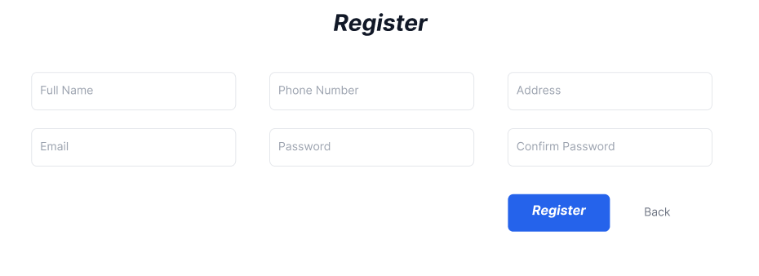  5. The customer enter their name, phone number, address, email and password twice and click register  6. The system display a success message
Exception | 6. The system display an “Email already in use” error message  6.1 The customer either check their email or type a different email in the box and click Register again

Views customer statistics by revenue
Use case | Views customer statistics by revenue
Actor | Management staff
Pre-condition | The staff has a management account
Post-condition | The staff can view the customer statistics
Main event | 1. The staff open the web  2. The system display the main interface  3. The management staff enter their username and password and click login  4. The system display the main employee interface  5. The staff click view statistics  6. The system display the view statistic function, with an option to view customer statistics  7. The staff clicks view customer statistics  8. The system show an interface with 2 box to enter start and end date  9. The staff enter start date, end date and click enter  10 The system display the list of all customer and their generated revenue in the given time period  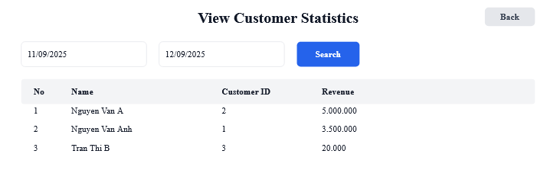  11. The staff click a customer  12. The system show all the transaction made by that customer in that time period  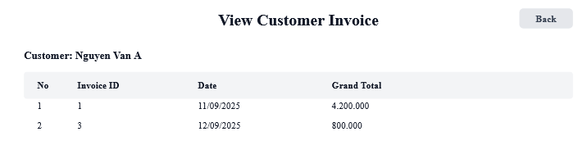  13. The staff click on a specific transaction  14. The system show the detail of that transaction, including date, time, list of item in the transaction, number of each item, discount and total  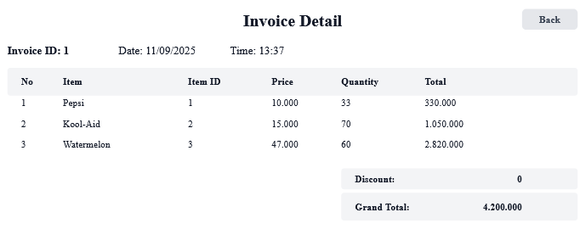
Exception | 4. The system display “Username or password incorrect” message  4.1. The staff type their credential correctly and click Login button  10. The system display no customer in the period  10.1 The staff enter a different time period and click search again

Entity class diagram

Step 1: Describe the system
The system is a web-based platform that supports the management and operation of an online supermarket and it’s user. Customers can register as members by selecting the registration menu, entering their personal information, and submitting it to be saved into the database. After registration, customers are able to search for items, place online orders, and also purchase products directly at the counter. Salers are able to sell items to customers directly at the counter. Warehouse staff can import items from suppliers, manage item and supplier information by adding, editing, or deleting records, browse online orders, and export them to delivery staff for delivery. Management staff can access statistical reports, with the option to view item, supplier or customer statistics by selecting a start and end date to review the list of customers along with their detailed transaction history or item with their related transactions or suppliers with their invoice in the given time period.

Step 2: Noun extraction
- Actor related noun:
  - Customer
  - Saler
  - Warehouse staff
  - Supplier
  - Delivery staff
  - Management staff
  - User
  - Staff
- Object related noun
  - Item
  - Order
  - Invoice
  - Supermarket
  - System
  - Menu
  - Report

Step 3: Noun evaluation
- System: too abstract
- Menu: too abstract
- Report: too abstract
- User -> Class User: name, password, address, email, phoneNumber, role
- Customer -> Class Customer(inherit from User)
- Staff -> Class Staff(inherit from User)
- Saler -> Class Saler(inherit from Staff)
- Warehouse staff -> Class WarehosueStaff(inherit from Staff)
- Management staff -> Class ManagerStaff(inherit from Staff)
- Delivery staff -> Class DeliveryStaff(inherit from Staff)
- Supplier -> Class Supplier: name, phoneNumber, email
- Item -> Class Item: name, price, description
- Order -> Class Order: date, status, totalAmount
- Online order -> Class OnlineOrder(inherit from Order): deliverAddress, deliverFee
- Direct order -> Class DirectOrder(inherit from Order)
- Invoice -> Class Invoice: billingAddress, grandTotal, discount, paymentMethod

Step 4: Determine quantity relationship between entity
  - Supplier – ImportInvoice: 1 – n
  - WarehouseStaff – ImportInvoice: 1 – n
  - ImportInvoice – Item: n – n -> Class ImportItem: quantity, price
  - Order – Item: n – n -> Class ItemOrder: quantity, price
  - Order – Invoice: 1 – 1
  - Customer – Order: 1 – n
  - Saler – DirectOrder: 1 – n
  - DeliveryStaff – OnlineOrder: 1 – n

Step 5: Determine object relationship between entity
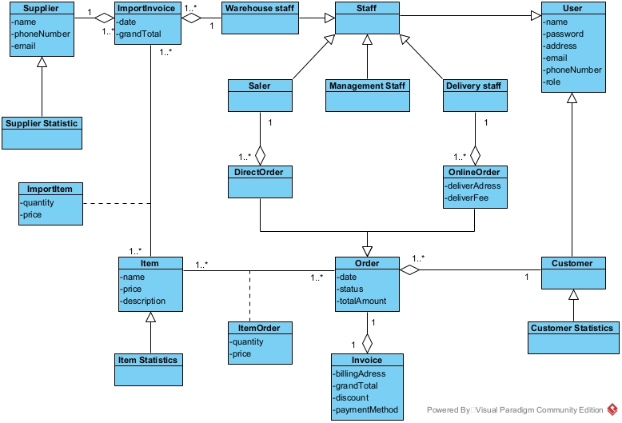

Extract and draw the class diagram for the module.

Module register as a member
- Customer access the app: Need a class MainMenuView:
+ Register button: subRegisterForm
- The system show a register form : Need a class RegisterView
+ Input for name: inName
+ Input for address: inAddress
+ Input for phone number: inPhoneNumber
+ Input for email: inEmail
+ Input for password: inPassword
+ Input for confirm password: inConfirmPassword
+ Register button: subRegister
+ Back button: subBack
- The customer register an account: Need a method register():
+ Input: name, address, phone number, email, password
+ Output: boolean
+ Assign to class Customer
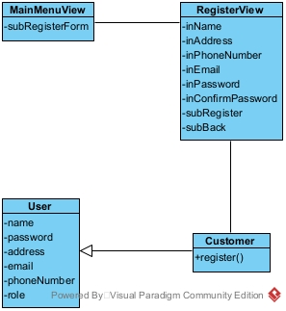

Module view customer statistics by revenue
- Management staff open the open and login : need a class LoginView
+ Input for username: inUsername
+ Input for password: inPassword
+ Login button: subLogin
- System displays an interface that has at least 1 button view statistic: Need a class StaffMenuView:
+ View statistics button: subStatistic
- System shows an interface that has at least 1 button view customer statistic: Need a class StatisticsView
+ View customer statistics button: subViewCustomerStatistics
- The system displays an interface to enter start and end date: Need a class CustomerStatisticsView
+ Input for start date: inStartDate
+ Input for end date: inEndDate
+ Display list of customer: outsubCustomerStatistics
+ Search button: subSearch
- Enter start and end date for customer statistics: Need a method getCustomerStatistics:
+ Input: start date, end date
+ Output: list of customer
+ Assign to class CustomerStatistics
- The system display an interface with list of a customer’s invoice: Need a class CustomerInvoiceView
+ List of invoice: outsubCustomerInvoice
+ Back button: subBack
- Get all invoice from a customer in a period: Need method getInvoiceByCustomer():
+ Input: customer id, start date, end date
+ Output: list of Invoice
+ Assign to class Invoice
- The system display an Invoice: Need a class InvoiceView
+ Invoice detail: outInvoiceDetail
+ Back button: subBack
- Get an invoice by id: Need a method getInvoice()
+ Input: invoice id
+ Output: invoice detail
+ Assign to class Invoice
- Get order detail from invoice: Need a class getOrder()
+ Input: invoice id
+ Output: List of item in the order
+ Assign to class Order

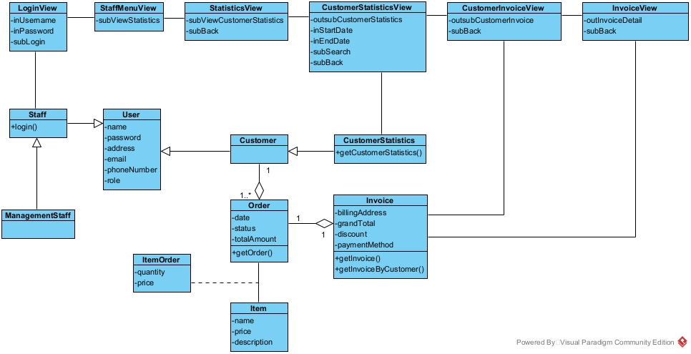

Draw the state diagram for the module.

Module register as a member
- From MainMenuView, clicking the register button, the system will move to RegisterView
- From RegisterView, after enter name, address, phone number, email, password, confirm password and click Register, the system will save the account and finish
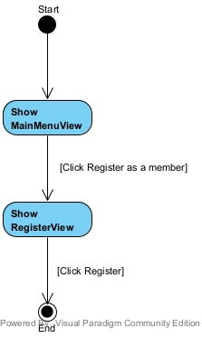

Module view customer statistics by revenue
- From LoginView, the management staff enter username, password and click Login, the system will display the StaffMenuView
- From StaffMenuView, the staff click Statistics, the system move to StatisticsView
- From StatisticsView, after clicking view Customer statistics, the CustomerStatisticsView will display
- From CustomerStatisticsView, after enter start date, end date and click enter, a list of customer will be display. After clicking a customer, the system will move to CustomerInvoiceView.
- From CustomerInvoiceView, after click on an Invoice, the system will display the InvoiceView
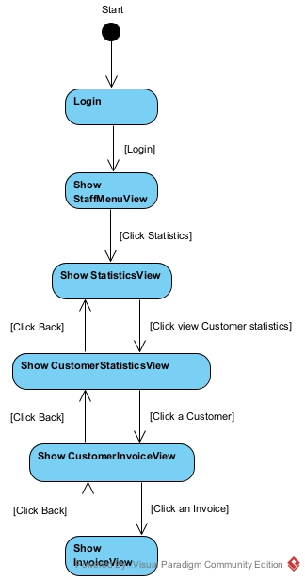

Write detail scenario(ver 2.0)

Module register as a member
- In main menu interface, customer click register
- Class MainMenuForm call the class RegisterForm
- The class RegisterForm display itself to the customer
- The customer input information and click register
- Class RegisterForm call the class Customer
- Class Customer execute register()
- Class Customer return the result to RegisterView
- Class RegisterView display success message

Module view customer statistics by revenue
- In the login interface, management staff enter username, password and click Login
- The class LoginView call the class Staff
- The class Staff execute login()
- The class staff return the result to the class LoginView
- The class LoginView call the class StaffMenuView
- The class StaffMenuView display to the management staff
- In main menu interface, management staff click view statistics
- Class StaffMenuView call the class StatisticsView
- The class StatisticsView display
- The staff click view customer statistics by revenue
- The class StatisticsView call the class CustomerStatisticsView
- The class CustomerStatisticsView display
- The staff enter date and click search
- The class CustomerStatisticsView call the class CustomerStatistics
- The class CustomerStatistics execute getCustomerStatistics
- The class CustomerStatistics return the result
- The class CustomerStatisticsView display the result
- The staff click a Customer
- The class CustomerStatisticsView call the class CustomerInvoiceView
- The class CustomerInvoiceView call the class Invoice
- The class Invoice execute getInvoiceByCustomer()
- The class Invoice return the result
- The class CustomerInvoiceView display the result
- The staff click an invoice
- The class CustomerInvoiceView call the class InvoiceView
- The class InvoiceView call the class Invoice
- The class Invoice execute getInvoice()
- The class Invoice call the class Order
- The class Order execute getOrder()
- The class Order return the result to the class Invoice
- The class Invoice return the result
- The class InvoiceView display the result

Draw the communication diagram for the module.

Module register as a member
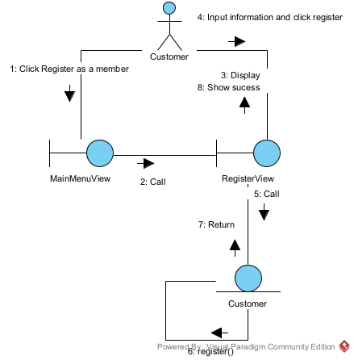

Module view customer statistics by revenue
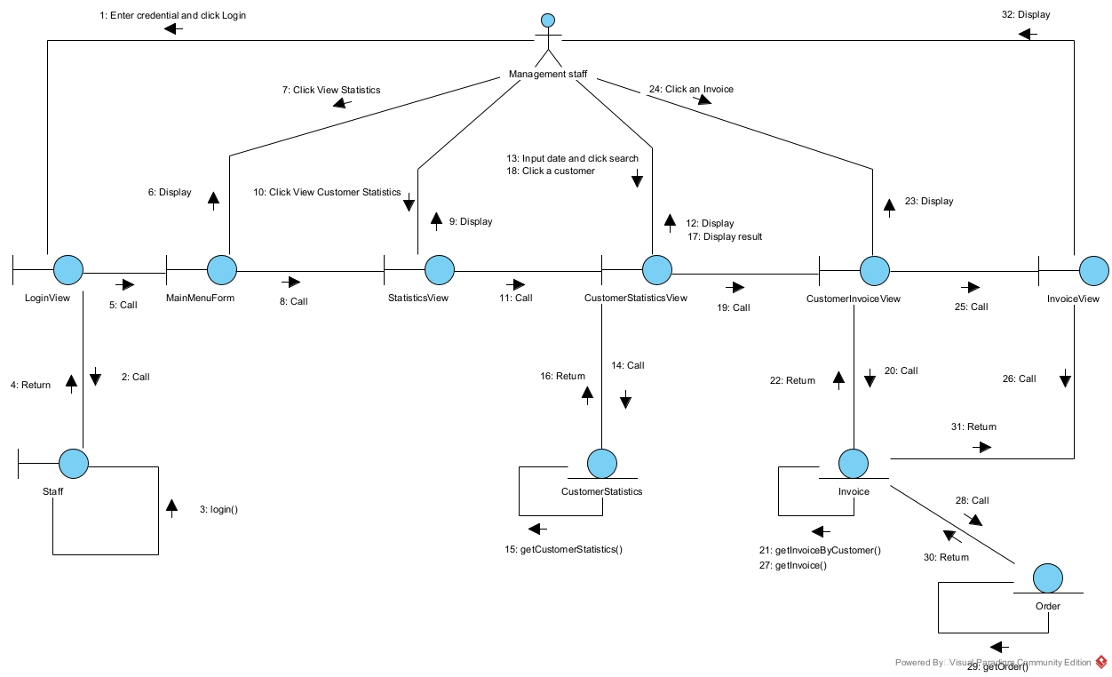

Draw the sequence diagram for the module.

Module register as a member
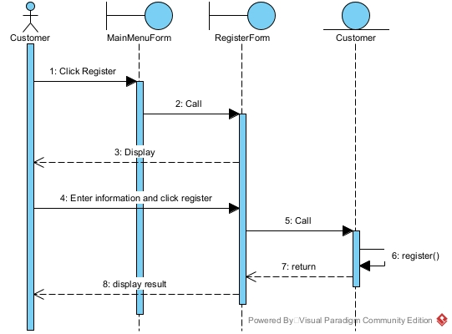

Module view customer statistics by revenue
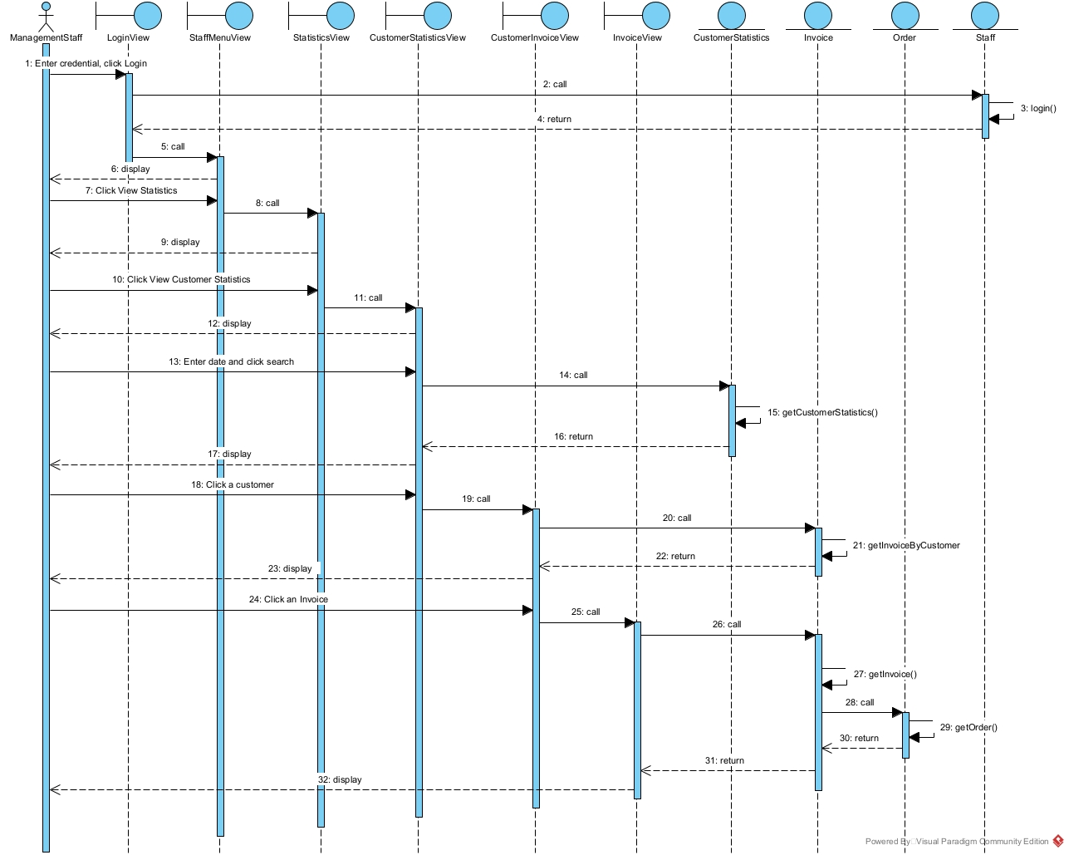

3. Use case diagram
a. General use case
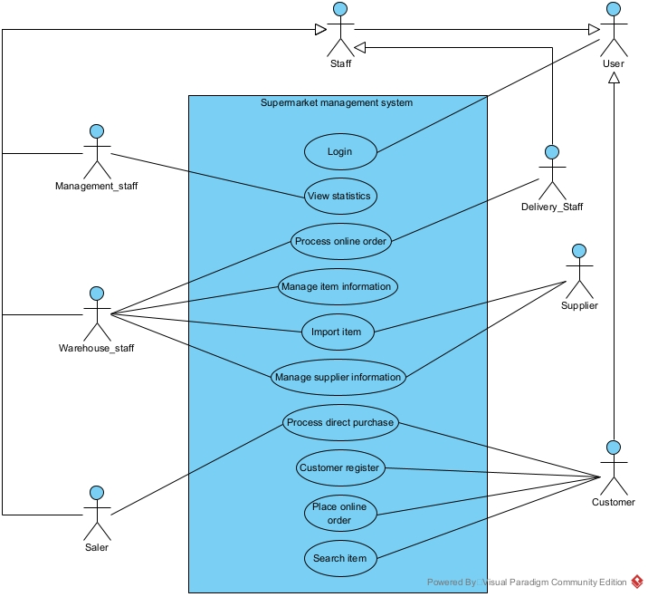
- Description:
  - Login: This use case enable the staff or customer to login into the supermarket system
  - Views statistics: This use case enable the management staff to view the statistic of item, supplier or customer
  - Process online order: This use case enable the warehouse staff to browse the online order place by customer, and can export them to the delivery staff
  - Manage item information: This use case enable the warehouse staff to add new item or change/delete existing item
  - Import item: This use case enable the warehouse staff to import item from supplier
  - Manage supplier information: This use case enable the warehouse staff to add new supplier or change/delete existing supplier
  - Process direct purchase: This use case enable the saler staff to process the direct purchase from customer at the counter
  - Customer register: This use case enable the customer to create an account to log into the system
  - Place online order: This use case enable the customer to place an online order through the system
  - Search item: This use case enable the customer to search the detail of an item through the system
b. Registers as a member
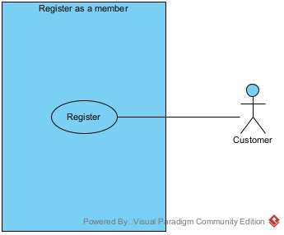
- Register: This use case enable the customer to register as a member in the system
c. Views customer statistics
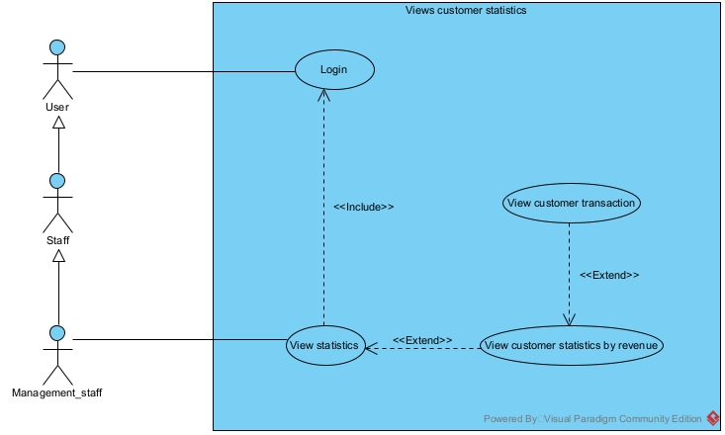
- Login: This use case enable the management staff to login into the system to view customer statistics
- View statistics: This use case enable the management staff to view the item statistics, customer statistics or item statistics
- View customer statistics: This use case enable the management staff to enter start and end date to view the customer statistics by revenue
- View customer transaction: This use case enable the management staff to view all the transaction related to a customer in a specific time frame

Design
Subject No. 12
An online supermarket management system enables management staff, warehouse staff, saler and customer to use:
- Management staff: view the types of statistics: items, suppliers and revenue.
- Warehouse staff: import goods from suppliers, manage (add, delete, change) item information and supplier information, browse online orders and export to delivery staff.
- Saler: selling goods at the counter to customers
- Customer: register as a member, search, order online, buy directly at the counter

Considering two modules and answering questions:
- Customer registers as a member: selects the member registration menu → enters customer information, clicks add → the system saves to the database.
- Management staff views customer statistics: selects the menu to view statistical reports → chooses to view customer statistics by revenue → selects the start and end date → Views statistics of customers → clicks on a customer to view details → views list of related transactions.

Entity class diagram
- Step 1: Add id attribute to all class that is not inherit from other class
- Step 2: Add attribute type for all attribute. Attribute type must compatible with the chosen programming language
- Step 3: Change all association relationship to aggregation/composition
  - ImportInvoice associate Item create ImportItem: Change to ImportItem include ImportInvoice and Item
  - Item associate Order create ItemOrder: Change to ItemOrder include Item and Order
- Step 4: Add class atribute to entity class
  - ImportInvoice has Supplier, WarehouseStaff
  - ImportItem has ImportInvoice, Item
  - DirectOrder has Saler
  - OnlineOrder has DeliveryStaff
  - ItemOrder has Item, Order
  - Order has Customer
  - Invoice has Order
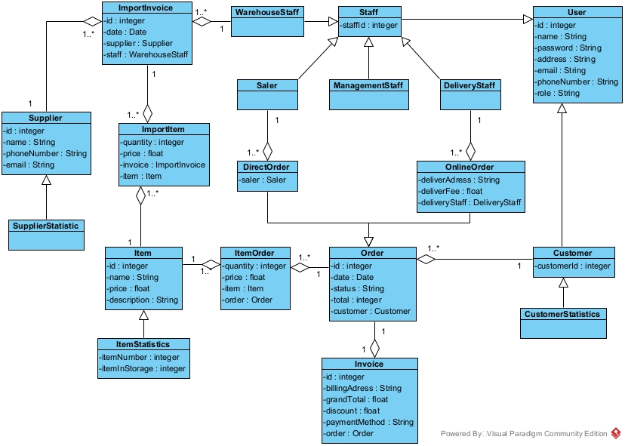

Database
- Step 1: For each class entity, create a table
  - User: tblUser
  - Staff: tblStaff
  - Customer: tblCustomer
  - Order: tblOrder
  - DirectOrder: tblDirectOrder
  - OnlineOrder: tblOnlineOrder
  - ImportInvoice: tblImportInvoice
  - Invoice: tblInvoice
  - Item: tblItem
  - Supplier: tblSupplier
  - ImportItem: tblImportItem
- Step 2: For each entity class, take all attribute type except entity attribute
  - tblUser:
    - id: integer(10)
    - name: varchar(255)
    - password: varchar(255)
    - address: varchar(255)
    - email: varchar(255)
    - phoneNumber: varchar(255)
    - role: varchar(255)
  - tblStaff:
    - staffId: integer(10)
    - tblUserid: integer(10)
  - tblCustomer:
    - customerId: integer(10)
    - tblUserid: integer(10)
  - tblOrder:
    - id: integer(10)
    - date: date
    - status: varchar(255)
    - total: float(10)
    - tblCustomercustomerId: integer(10)
  - tblInvoice:
    - id: integer(10)
    - billingAddress: varchar(255)
    - discount: float(10)
    - grandTotal: float(10)
    - paymentMethod: varchar(255)
    - tblOrderid: integer(10)
  - tblItemOrder
    - quantity: integer(10)
    - price: float(10)
    - tblItemid: integer(10)
    - tblOrderid: integer(10)
  - tblItem
    - id: integer(10)
    - name: varchar(255)
    - price: float(10)
    - description: varchar(255)
  - tblDirectOrder
    - tblStaffstaffId: integer(10)
    - tblOrderid: integer(10)
  - tblOnlineOrder
    - tblStaffstaffId: integer(10)
    - tblOrderid: integer(10)
    - deliverAdress: varchar(255)
    - deliverFee: integer(10)
  - tblImportInvoice
    - id: integer(10)
    - date: date
    - tblStaffstaffId: integer(10)
    - tblSupplierid: integer(10)
  - tblImportItem
    - quantity: integer(10)
    - price: float (10)
    - tblItemid: integer(10)
    - tblImportInvoiceid: integer(10)
  - tblSupplier
    - id: integer(10)
    - name: varchar(255)
    - phoneNumber: varchar(10)
    - email: varchar(255)
- Step 3: Consider quantity relationship between classes:
  - tblUser – tblStaff: 1 – 1
  - tblUser – tblCustomer: 1 – 1
  - tblStaff – tblDirectOrder: 1 – n
  - tblStaff – tblOnlineOrder: 1 – n
  - tblDirectOrder – tblOrder: 1 – 1
  - tblOnlineOrder – tblOrder: 1 – 1
  - tblCustomer – tblOrder: 1 – n
  - tblOrder – tblInvoice: 1 – 1
  - tblOrder – tblItemOrder: 1 – n
  - tblItem – tblItemOrder: 1 – n
  - tblStaff – tblImportInvoice: 1 – n
  - tblSupplier – tblImportInvoice: 1 – n
  - tblImportInvoice – tblImportItem: 1 – n
  - tblItem – tblImportItem: 1 -n
- Step 4: Add primary key and foreign key for all table
  - tblUser:
    - Primary Key: id
  - tblStaff:
    - Primary Key: staffId
    - Foreign Key: tblUserid → tblUser.id
  - tblCustomer:
    - Primary Key: customerId
    - Foreign Key: tblUserid → tblUser.id
  - tblOrder:
    - Primary Key: id
    - Foreign Key: tblCustomercustomerId → tblCustomer.customerId
  - tblInvoice:
    - Primary Key: id
    - Foreign Key: tblOrderid → tblOrder.id
  - tblItemOrder:
    - Primary Key: tblItemid, tblOrderid
      - Foreign Keys: tblItemid → tblItem.id,t blOrderid → tblOrder.id
  - tblItem:
    - Primary Key: id
  - tblDirectOrder:
    - Primary Key: tblOrderid
    - Foreign Keys: tblStaffstaffId → tblStaff.staffId, tblOrderid → tblOrder.id
  - tblOnlineOrder:
    - Primary Key: tblOrderid
    - Foreign Keys: tblStaffstaffId → tblStaff.staffId, tblOrderid → tblOrder.id
  - tblImportInvoice:
    - Primary Key: id
    - Foreign Keys: tblStaffstaffId → tblStaff.staffId, tblSupplierid → tblSupplier.id
  - tblImportItem:
    - Primary Key: tblItemid, tblImportInvoiceid
    - Foreign Keys: tblItemid → tblItem.id, tblImportInvoiceid → tblImportInvoice.id
  - tblSupplier
    - Primary Key: id
- Step 5: Remove abundant attribute
  - Attribute total in order
  - Attribute grandTotal in invoice
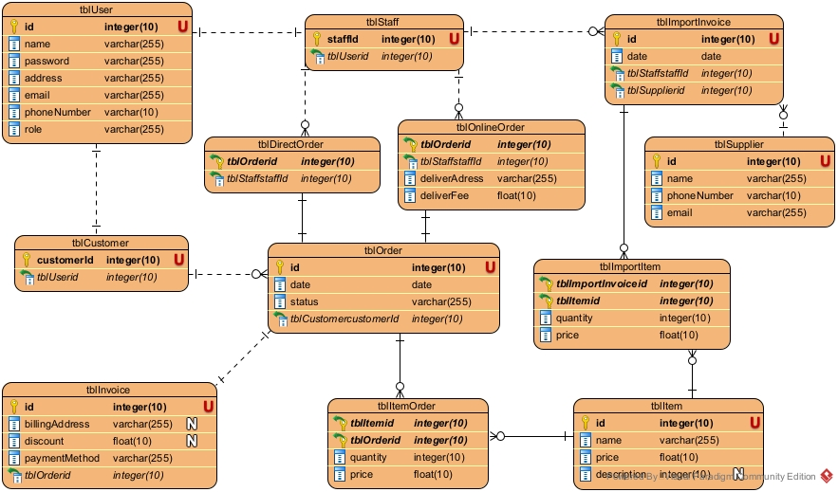

Class diagram

Module register as a member
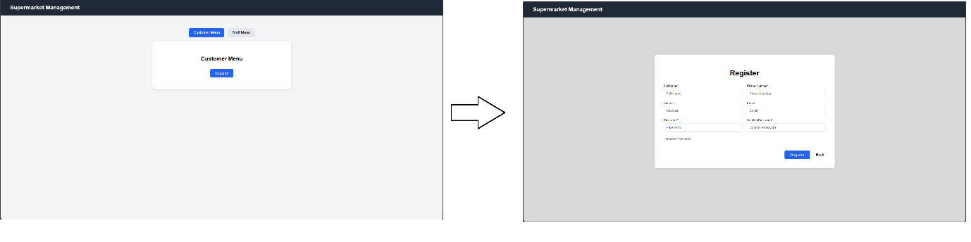
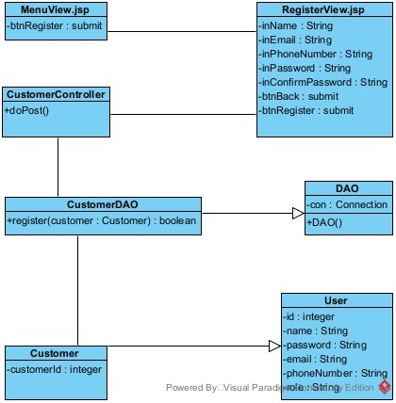

Module view customer statistics by revenue

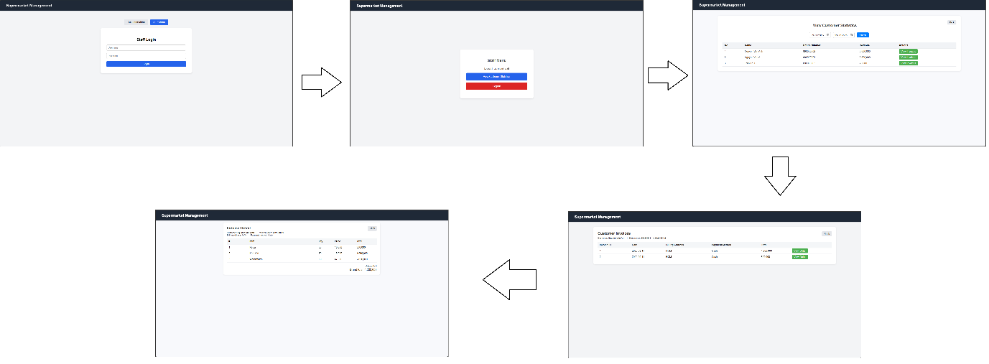

Activity diagram

Module register as a member
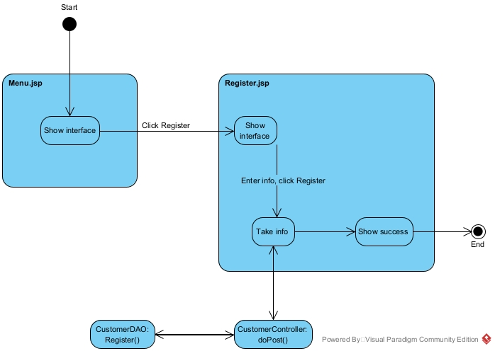

Module view customer statistics by revenue

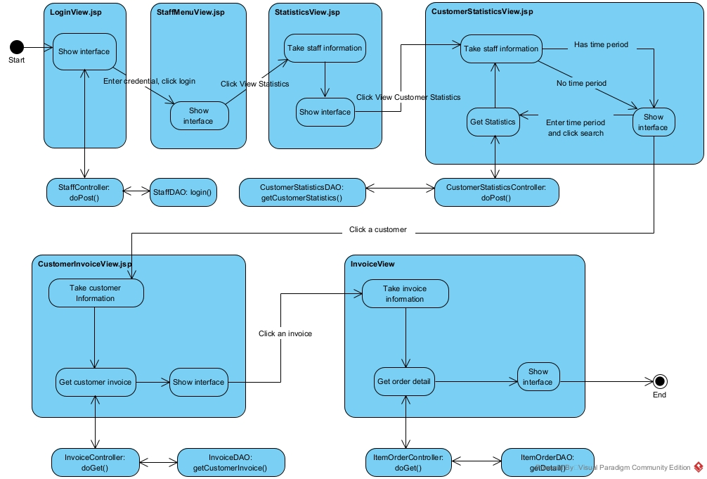

Scenario 3.0

Module register as customer
- In main menu interface, customer click register
- The interface MenuView.jsp call the interface RegisterView.jsp
- The interface RegisterView.jsp display itself to the customer
- The customer input information and click register
- The interface RegisterView.jsp call the class CustomerController
- The class CustomerController execute doPost()
- The class CustomerController call the class Customer
- The class Customer pack the information to a Customer object
- The class Customer return the Customer object to the class CustomerController
- The class CustomerController call the class CustomerDAO
- The class CustomerDAO execute register()
- The class CustomerDAO return the result to the class CustomerController
- The class CustomerController return the result to the interface RegisterView.jsp
- Class RegisterView.jsp display success message

Module view customer statistics by revenue
- In StaffLoginView.jsp, management staff enter username, password and click login
- The interface MenuView.jsp call the class StaffController
- The class StaffController execute doPost()
- The class StaffController call the class Staff
- The class Staff pack the information into a Staff object
- The class Staff return the object to the class StaffController
- The class StaffController call the class StaffDAO
- The class StaffDAO execute login()
- The class StaffDAO return the result to the class StaffController
- The class StaffDAO call the interface StaffMenuView.jsp
- The interface StaffMenuView.jsp display to the management staff
- The management staff click the View statistics button
- The interface StaffMenuView.jsp call the interface StatisticsView.jsp
- The interface CustomerStatisticsView.jsp display to the management staff
- The staff click View customer statistics by revenue
- The interface StatisticsView.jsp call the interface CustomerStatisticsView.jsp
- The interface CustomerStatisticsView.jsp display to the management staff
- The staff enter date and click search
- The interface CustomerStatisticsView.jsp call the class CustomerStatisticsController
- The class CustomerStatisticsController execute doPost()
- The class CustomerStatisticsController call the class CustomerStatisticsDAO
- The class CustomerStatisticsDAO execute getCustomerStatistics()
- The class CustomerStatisticsDAO call the class CustomerStatistics
- The class CustomerStatistics pack the information into a CustomerStatistics object
- The class CustomerStatistics return the object to the class CustomerStatisticsDAO
- The class CustomerStatisticsDAO return the result to the class CustomerStatisticsController
- The class CustomerStatisticsController return the result to the interface CustomerStatisticsView.jsp
- The interface CustomerStatisticsView.jsp display the result to the management staff
- The management staff click a customer
- The interface CustomerStatisticsView.jsp call the interface CustomerInvoiceView.jsp
- The interface CustomerInvoiceView.jsp call the class InvoiceController
- The class InvoiceController execute doGet()
- The class InvoiceController call the class InvoiceDAO
- The class InvoiceDAO execute getCustomerInvoice()
- The class InvoiceDAO call the class Invoice
- The class Invoice pack the information into an Invoice object
- The class Invoice return the result to the class InvoiceDAO
- The class InvoiceDAO return the result to the class InvoiceController
- The class InvoiceController return the result to the interface CustomerInvoiceView.jsp
- The interface CustomerInvoiceView.jsp display the result
- The management staff click an invoice
- The interface CustomerInvoiceView.jsp call the interface InvoiceView.jsp
- The interface InvoiceView.jsp call the class ItemOrderController
- The class ItemOrderController execute deGet()
- The class ItemOrderController call the class ItemOrderDAO
- The class ItemOrder execute the function getOrderDetail()
- The class ItemOrder call the class Item
- The class Item pack the information into an Item object
- The class Item return the object to the class ItemOrderDAO
- The class ItemOrderDAO call the class ItemOrder
- The class ItemOrder pack the information into an ItemOrder object
- The class ItemOrder return the result to the class ItemOrderDAO
- The class ItemOrderDAO return the result to the class ItemOrderController
- The class ItemOrderController return the result to the interface InvoiceView.jsp
- The interface InvoiceView.jsp display the result to the management staff

Sequence diagram

Module register as a member
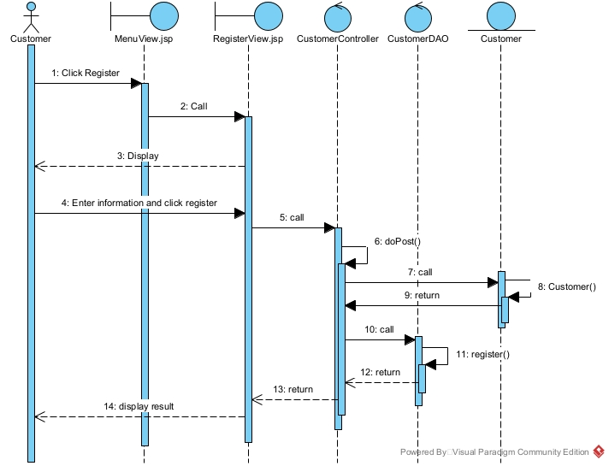

Module view customer statistics by revenue
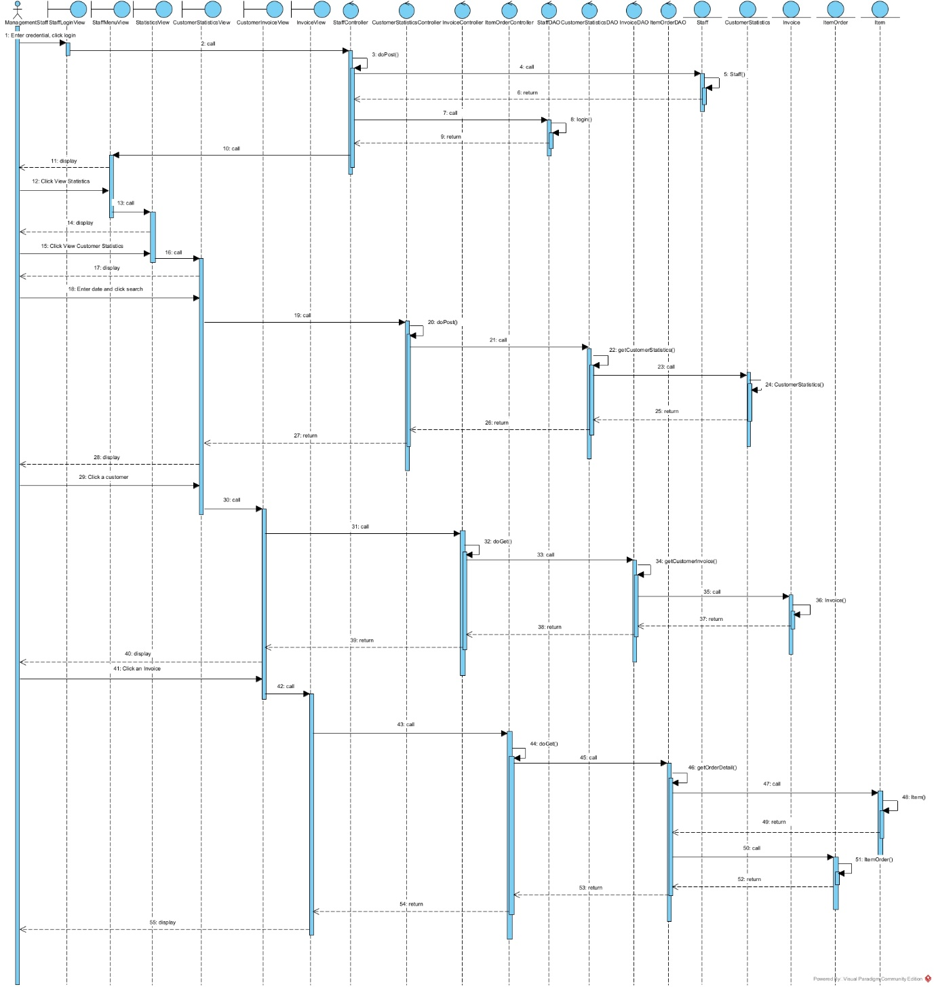

Package Diagram
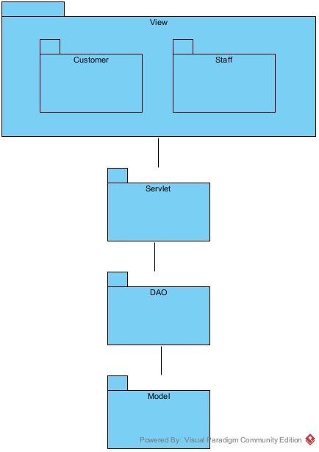

Deployment Diagram
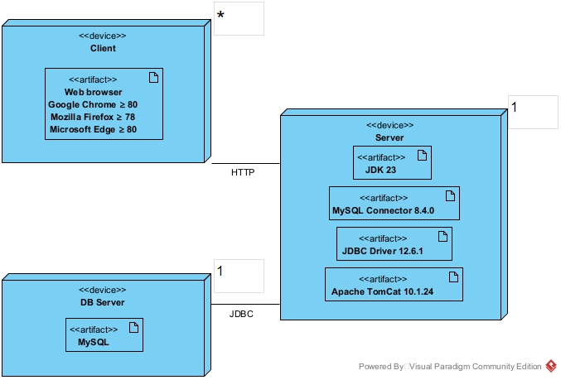

Coding

Source code
https://drive.google.com/drive/folders/1MsHIOBD0ghzR2SxAutNGTvx2a4K9V3GR?usp=sharing

File Structure
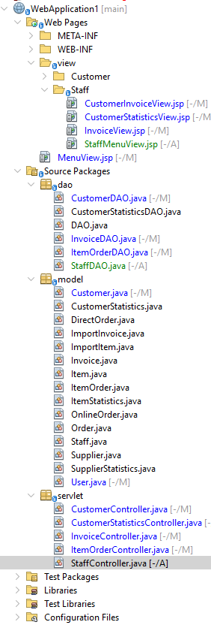

Interface
MenuView.jsp for customer
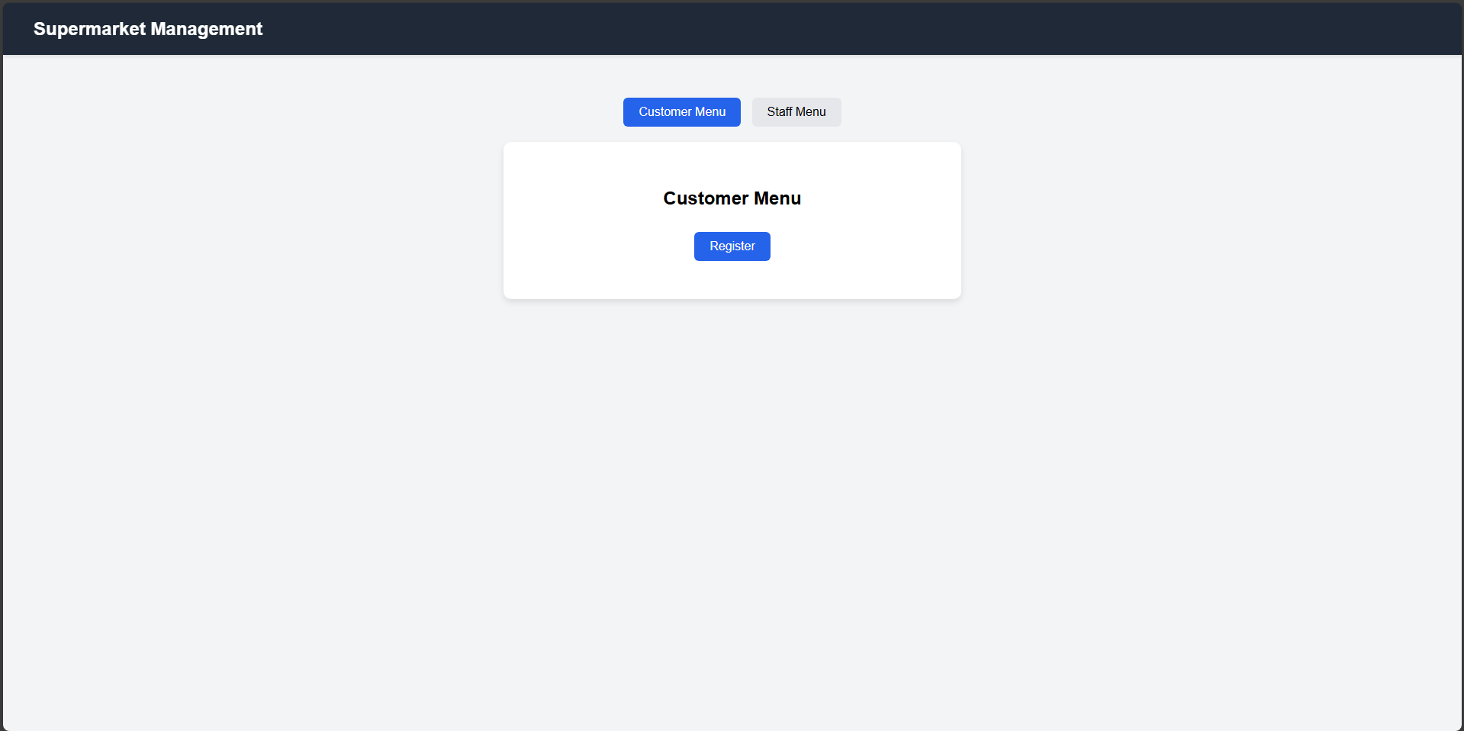
RegisterView.jsp
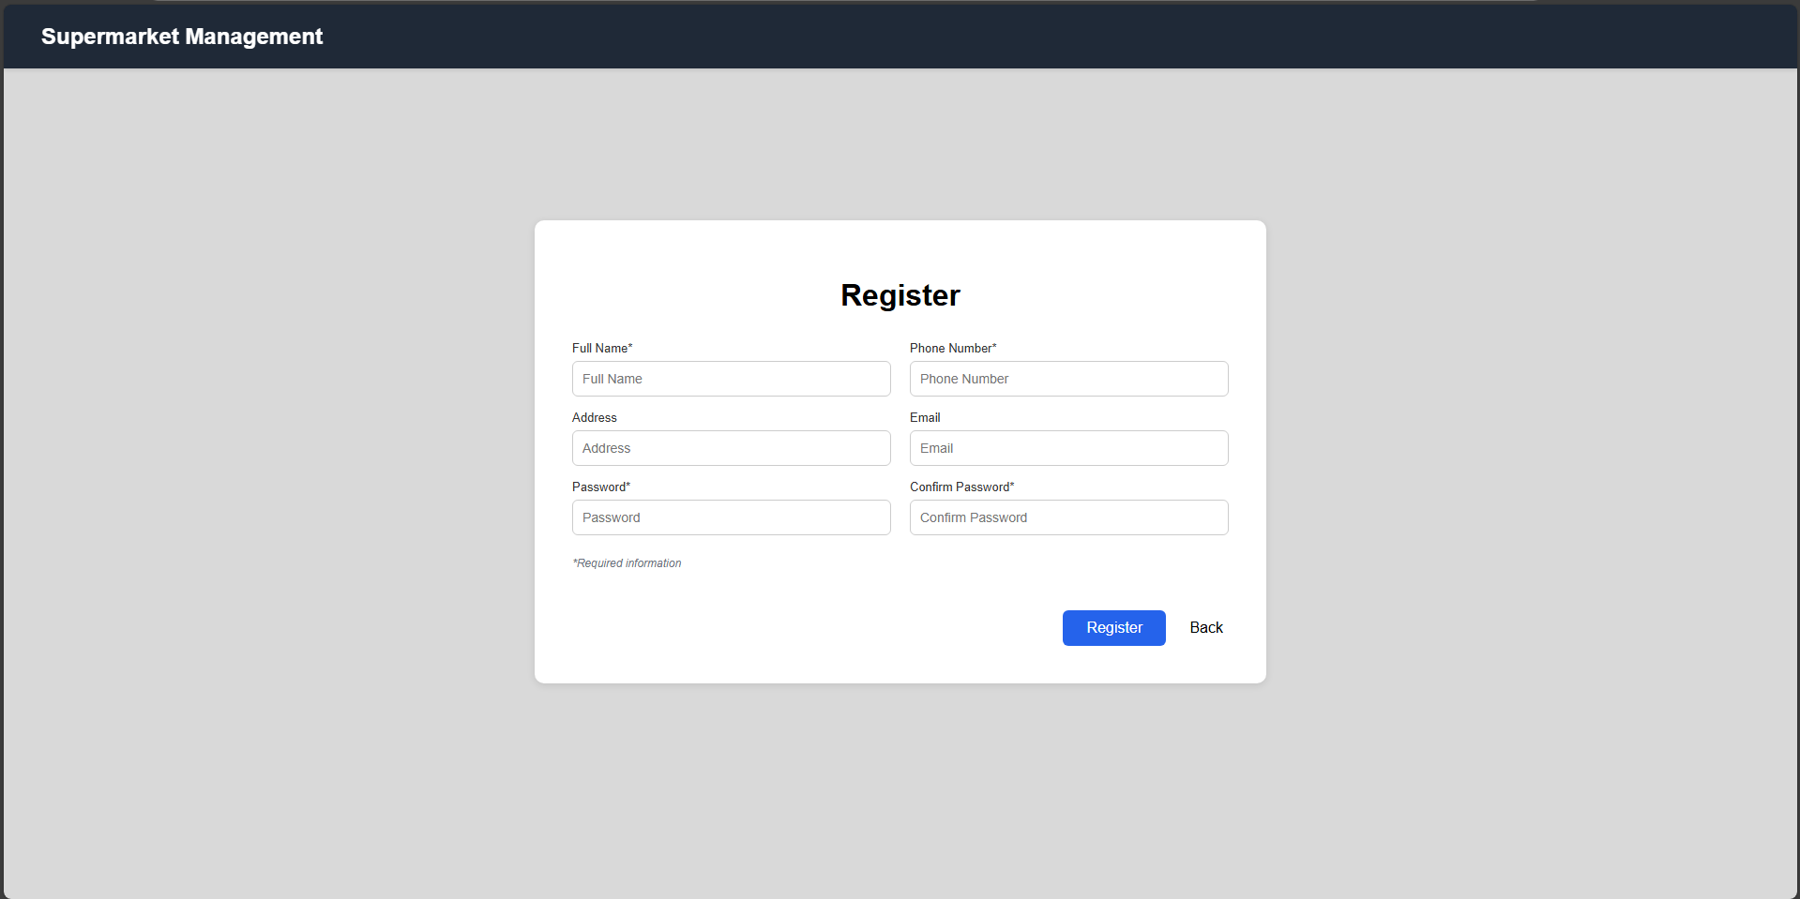
MenuView.jsp for staff
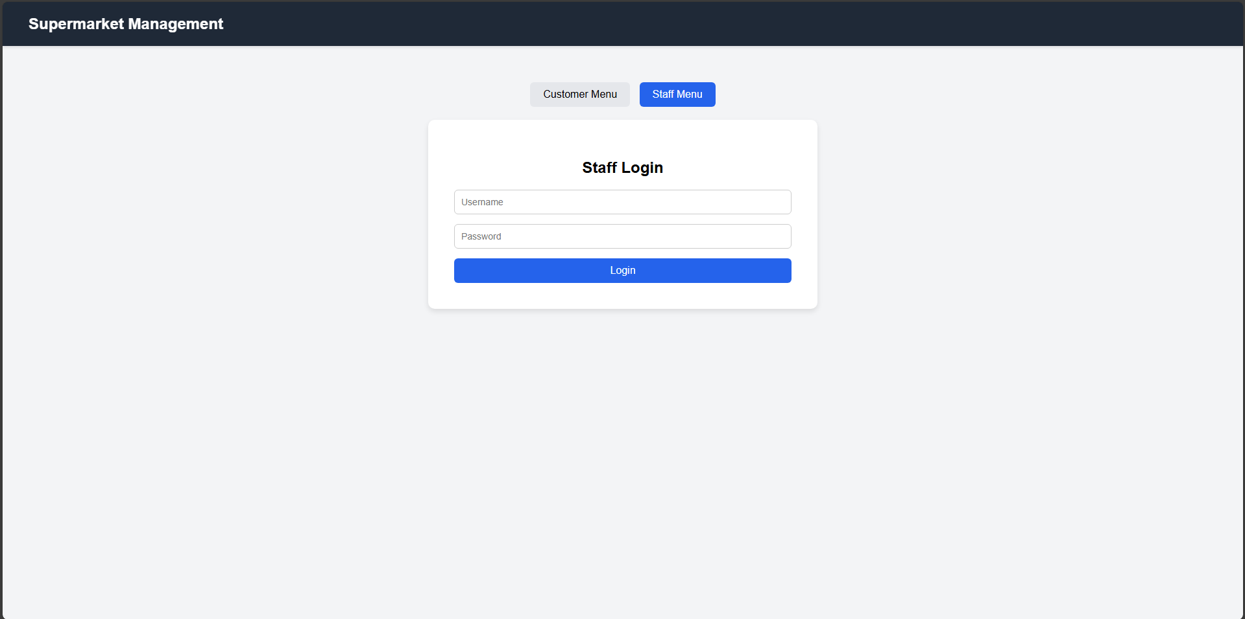
StaffMenuView.jsp
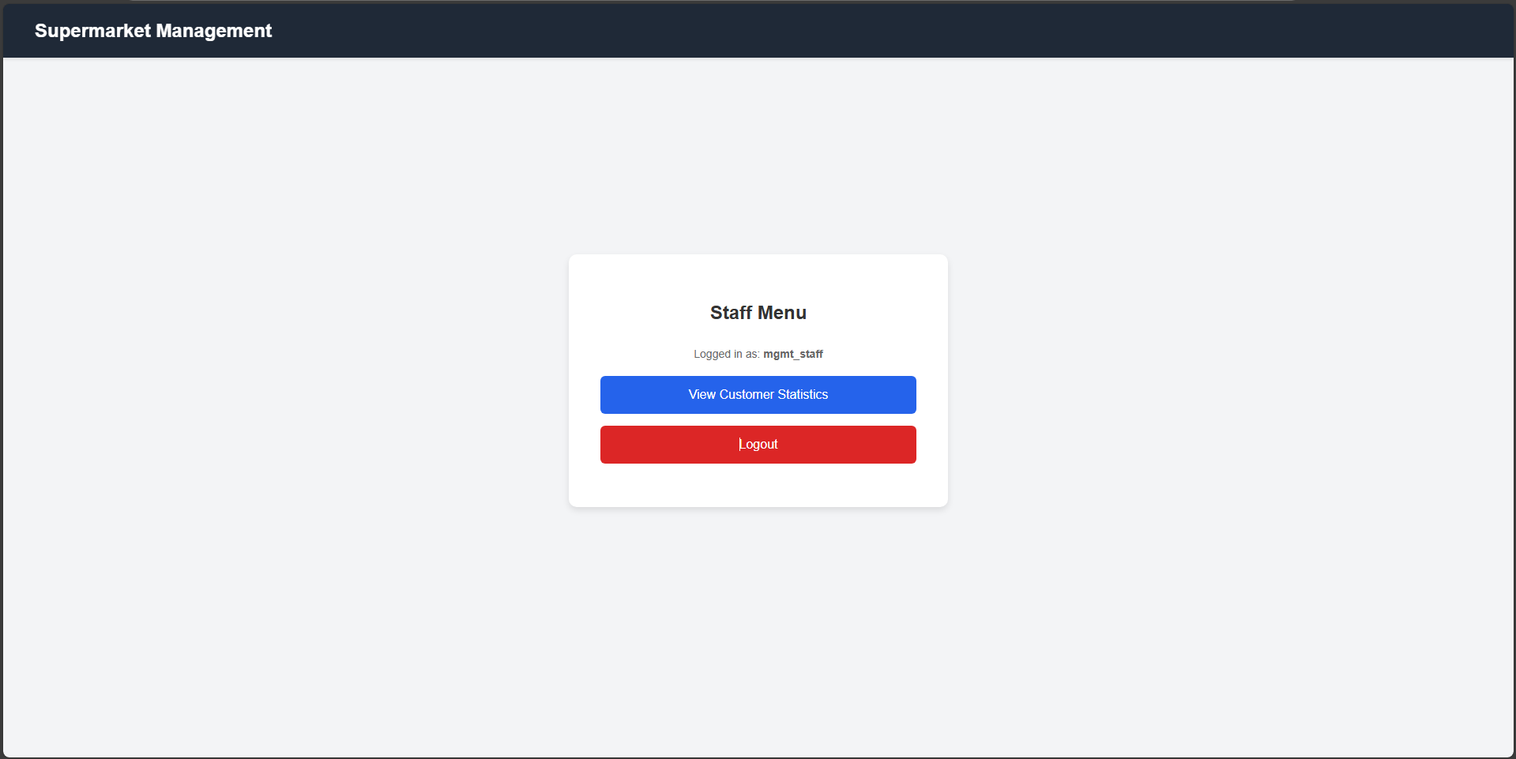
CustomerStatisticsView.jsp
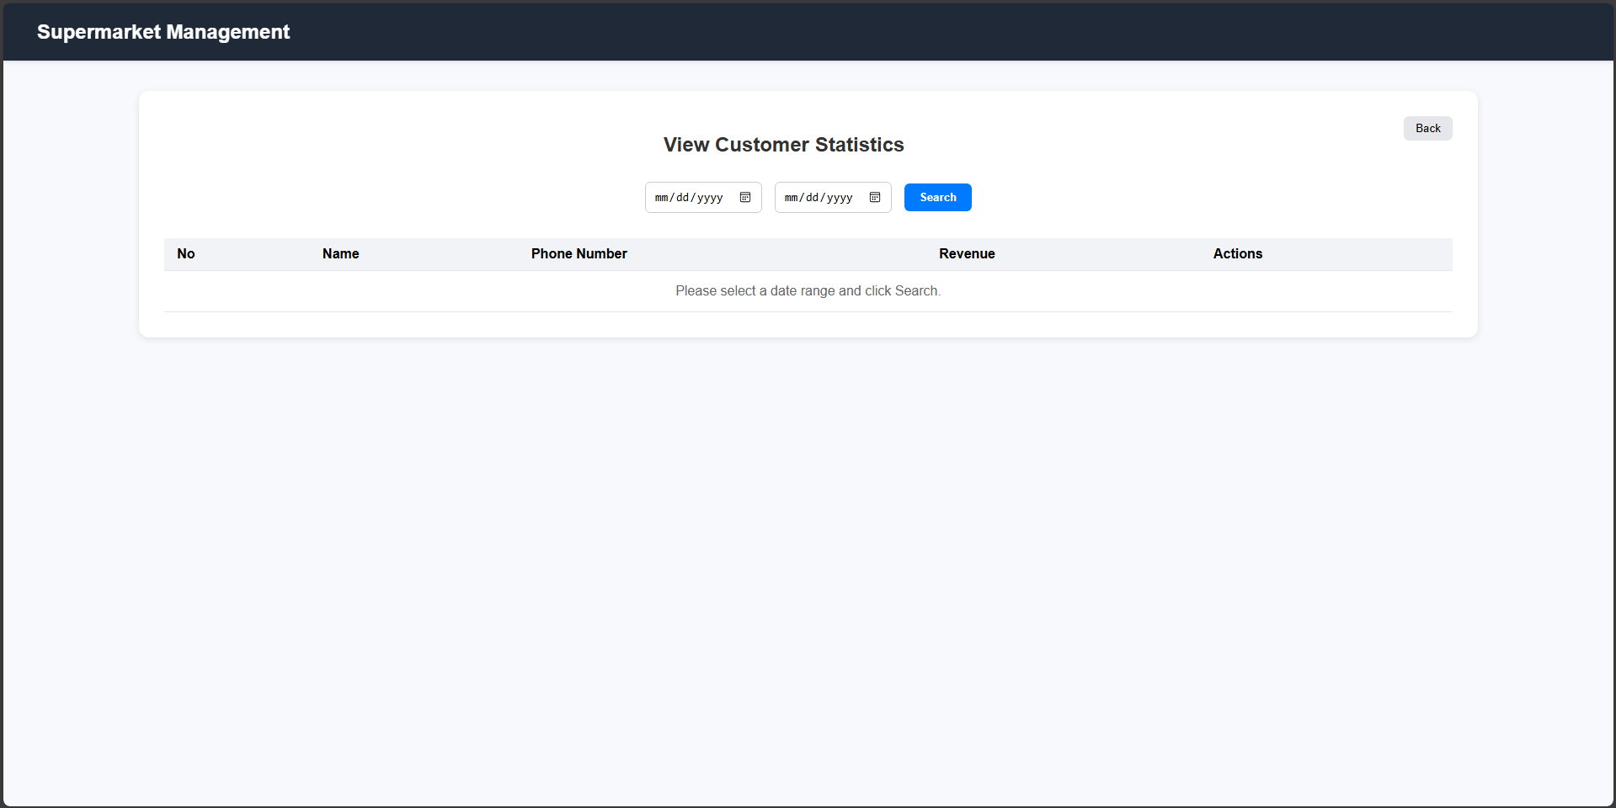
CustomerInvoiceView.jsp
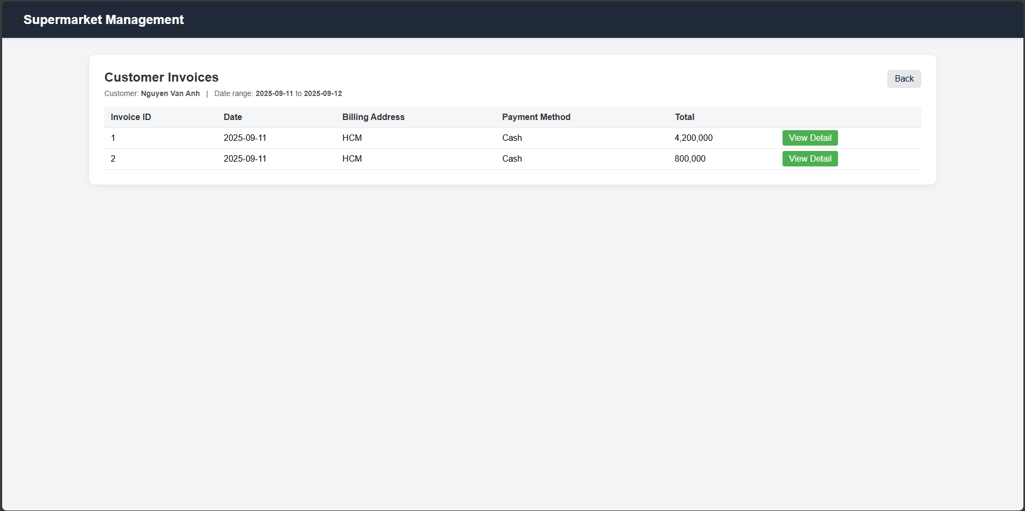
InvoiceView.jsp
